**DAILY ONLINE ACTIVITIES SUMMARY**

|  |  |  |  |  |  |  |  |
| --- | --- | --- | --- | --- | --- | --- | --- |
| **Date:** | **08-06-2020** | | | | **Name:** | **Harshitha M** | |
| **Sem & Sec** | **8th 'A'** | | | | **USN:** | **4AL16CS038** | |
| **Online Test Summary** | | | | | | | |
| **Subject** | | **SMS** | | | | | |
| **Max. Marks** | | **60** | | **Score** | | **54** | |
| **Certification Course Summary** | | | | | | | |
| **Course** | **Python for machine learning** | | | | | | |
| **Certificate Provider** | | | **Great learning** | **Duration** | | | **1hr** |
| **Coding Challenges** | | | | | | | |
| **Problem Statement:C progam to print right angled traigle numbers** | | | | | | | |
| **Status:Solved** | | | | | | | |
| **Uploaded the report in Github** | | | | **Yes** | | | |
| **If yes Repository name** | | | | **Harshitha-M** | | | |
| **Uploaded the report in slack** | | | | **Yes** | | | |

Online Test Details: (Attach the snapshot and briefly write the report for the same)

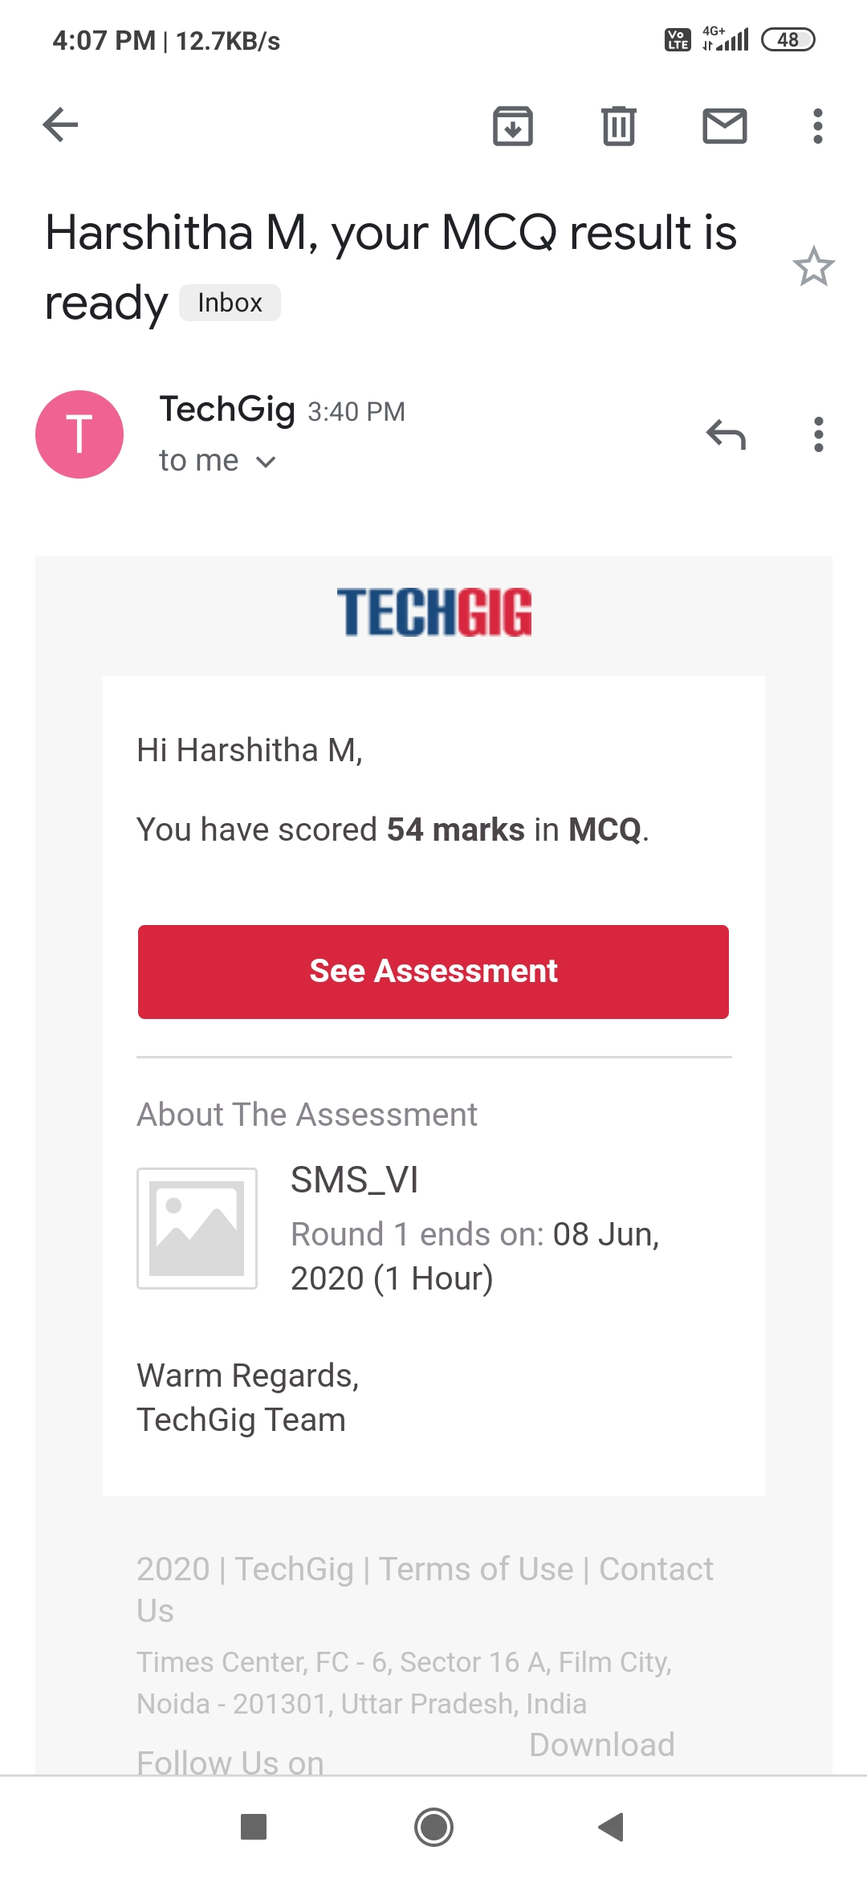

Certification Course Details: (Attach the snapshot and briefly write the report for the same)

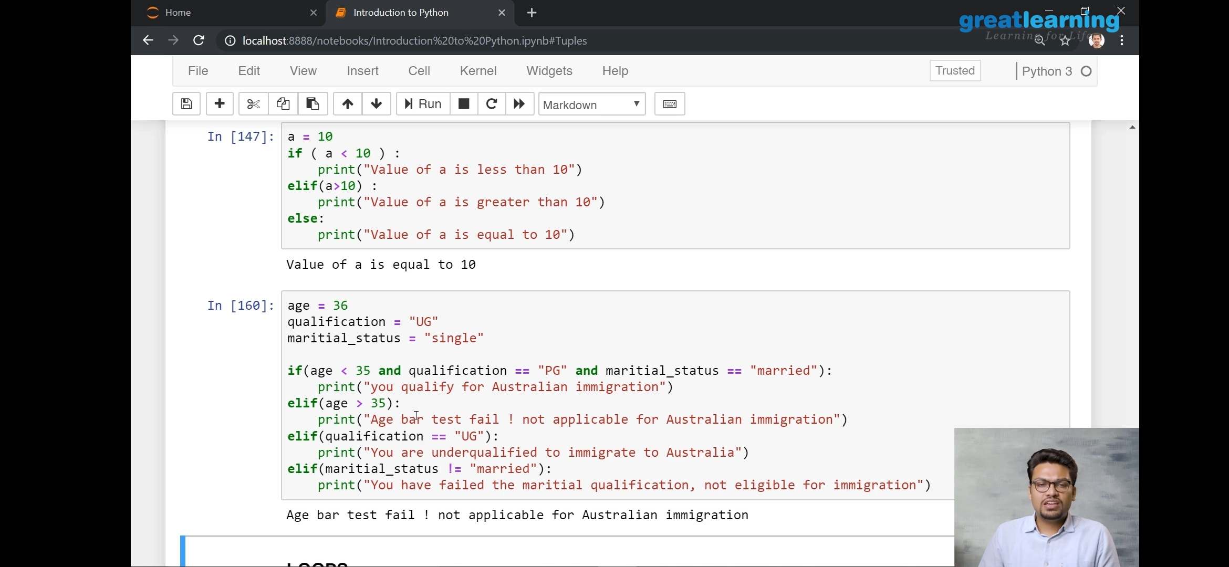

Coding Challenges Details: (Attach the snapshot and briefly write the report for the same)

Program no:1

importjava.util.Scanner;

classFloydTriangle

{

publicstaticvoidmain(Stringargs[])

{

intn,num=1,c,d;

Scannerin=newScanner(System.in);

System.out.println("EnterthenumberofrowsofFloyd'striangleto

display");

n=in.nextInt();

System.out.println("Floyd'striangle:");

for(c=1;c<=n;c++)

{

for(d=1;d<=c;d++)

{

System.out.print(num+"");

num++;

}

System.out.println();

}

}

}